# GatherAll - Technical Design Document

## Table of Contents

1. Introduction
2. System Overview
3. Architecture
   * High-Level Architecture
   * Component Interactions
4. Backend Design
   * Technologies Used
   * Project Structure
   * API Design
   * Database Schema
   * Middleware
5. Frontend Design
   * Technologies Used
   * Project Structure
   * Routing
   * State Management
   * Key Components
6. Security Considerations
7. Deployment Plan
8. Future Plans
9. Conclusion

# Introduction and System Overview



## Introduction

**GatherAll** is a modern Metaverse Platform designed to enable users to create virtual spaces, invite people and have fun in the Virtual World. The platform offers a seamless user experience with features like real-time updates, user authentication.

This design document provides a comprehensive overview of the project's architecture, components, technology stack, and design decisions. It aims to serve as a guide for developers, stakeholders, and contributors.



## System Overview

Markd is built using the PERN stack (PostrgeSQL, Express.js, React, Node.js), utilizing modern web development practices. The application is structured to provide scalability, maintainability, and a responsive user experience across devices.

# Architecture



### High-Level Architecture

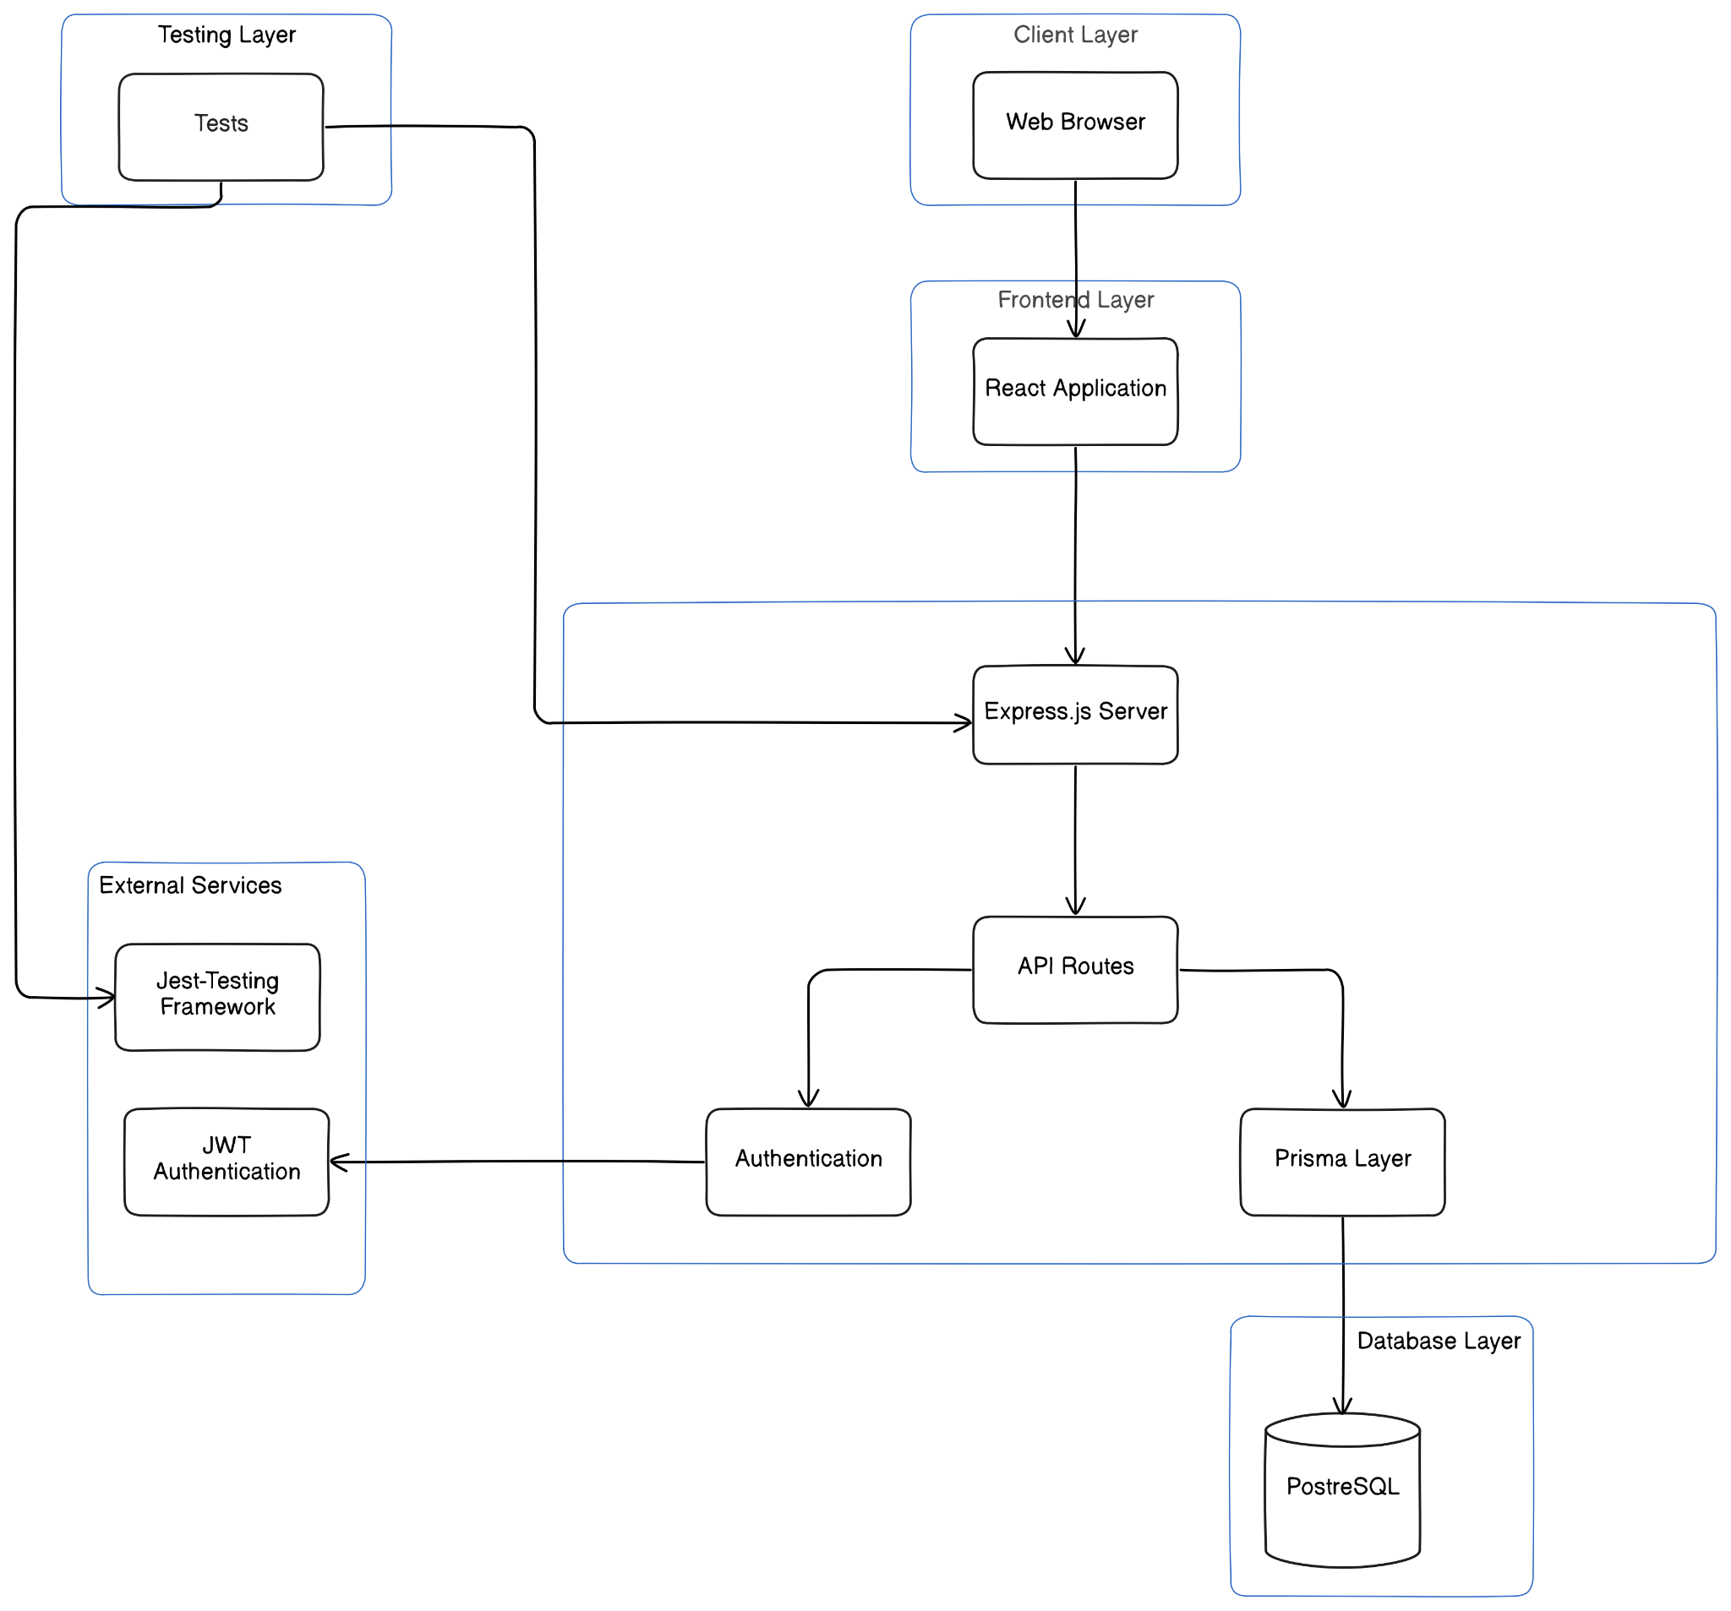

The system follows a three-tier architecture, comprising:

1. **Frontend**: Developed with React.js, responsible for the client-side user interface and interactions.
2. **Backend API**: Built with Express.js and Node.js, handling server-side logic, API endpoints, authentication, and business logic.
3. **Testing:** Developed using JS Testing library Jest.
4. **Database**: Utilizes PostgreSQL for storing user data and related information.

# Backend Design



### Technologies Used

* + **Node.js**: JavaScript runtime environment.
  + **Express.js**: Web application framework for building APIs.
  + **PostgreSQL**: SQL database for data storage.
  + **Prisma**: ORM (Object Relational Model) library for PostgreSQL.
  + **Turbo:** Provides Monorepo template for projects
  + **JWT**: JSON Web Tokens for authentication.

### Project Structure

* + **apps/http/src/index.js**: Entry point of the server application.
  + **apps/http/src/middlewares/**: Contains middleware functions, including authentication.
  + **packages/db/**:Prisma Package for Database access.
  + **apps/http/src/routes/v1**: Defines Version 1 API endpoints for authentication, users, admin, space.
  + **apps/http/scrypt.js**: Script for generating Hashing Passwords (Bcrypt was throwing some random errors).
  + **apps/ws/:** Contains all the Web Socket Logic
  + **packages/db:** All the db logic exported as a module and available for all app use

# Backend Design - API, Database Schema and Middlewares



### API Design

The backend exposes RESTful API endpoints categorized under:

#### User (/api/v1)

* + - POST /signup: User Signup.
    - POST /signin: User login and JWT token issuance.
    - POST /user/metadata: To retrieve User MetaData from the Database.
    - GET /avatars: Retrieve the Avatars.
    - GET /user/metadata/bulK?ids=[x,y,z]:Retrieve Metadata corresponding to multiple ids.

#### Space (/api/v1/space)

* + - POST /: Creates a new Space
    - DELETE /:spaceId: Deletes the space corresponding to spaceId
    - GET /all: Retrieve all existing spaces.
    - GET /:spaceId :Get space info corresponding to spaceId.
    - POST /element: Creates a new Element.
    - DELETE /element: Deletes the Element.

#### Admin (/api/v1/admin)

* + - POST /element: Creates a new Element
    - PUT /element/:elementId : Updates an Element
    - POST /avatar: Creates a new Avatar.
    - GET /map :Creates a new Map.

### WebSocket Design

The backend exposes RESTful API endpoints categorized under:

#### Client Sent Events

* + - Join A Space
    - Move within a Space

#### Server Sent Events

* + - Space Joined
    - Movement Rejected
    - Move
    - Leave
    - Join Event

# Database Schema



#### User Model

#### Fields:

* + **username**
  + **password**
  + **avatarId**
  + **role**



#### Space Model

#### Fields:

* + **name**
  + **width**
  + **height**
  + **thumbnail**

#### spaceElements Model

#### Fields:

* + **elementId**
  + **spaceId**
  + **x**
  + **y**

#### spaceElements Model

#### Fields:

* + **elementId**
  + **spaceId**
  + **x**
  + **y**

#### Element Model

#### Fields:

* + **width**
  + **height**
  + **imageUrl**

#### Map Model

#### Fields:

* + **width**
  + **height**
  + **name**

#### mapElements Model

#### Fields:

* + **mapId**
  + **elementId**
  + **x**
  + **y**

#### Avatar Model

#### Fields:

* + **imageUrl**
  + **name**

**Middlewares**

### Authentication Middleware

* + Validates JWT tokens sent in the Authorization header.
  + Attaches the authenticated user's information to the request object.
  + Protects routes that require authentication.

# Frontend Design



### Technologies Used

* + **React.js**: JavaScript library for building user interfaces.
  + **React Router DOM**: Handling client-side routing.
  + **Tailwind CSS**: Utility-first CSS framework for styling.
  + **Vite**: Build tool for faster development.
  + **ESLint**: Linting utility to maintain code quality.

### Project Structure

* + **main.jsx**: Entry point of the React application.
  + **App.jsx**: Main application component.
  + **app.css**: Global CSS and Tailwind directives.
  + **Game.jsx:** Game logic in totality

# Frontend Design - Routing, State Management and Key Components



### Routing

Implemented using React Router:

* + /: Landing Page

### State Management

#### Data Fetching:

* + - Utilizes fetch API.
    - Handles loading and error states.

### Key Components

### Game Screen

* + Main Game screen showing the player token and roomI

# Security Considerations



### Authentication

#### JWT Tokens:

* + - Securely generated and signed with a secret key.
    - Stored in the client's localStorage.

#### Password Security:

* + - Passwords hashed using scrypt.js before storing in the database.
    - Plain passwords are never stored or logged.

### Authorization

#### Protected Routes:

* + - Backend routes require valid JWT tokens.
    - Frontend routes use higher-order components to restrict access.

# Deployment Plans



### Environment Setup

#### Backend Environment Variables:

* + - JWT_SECRET and JWT_PASSWORD: Secret key for signing JWTs.

#### Frontend Environment Variables:

* + - VITE_WS_URL: Base URL for the WS Server.

### Deployment Steps

#### Backend Deployment:

* + Host on platforms like Heroku, AWS EC2, or DigitalOcean.
  + Ensure environment variables are securely set.

#### Frontend Deployment:

* + Build the React application using npm run build.
  + Host static files on services like Vercel or AWS.

#### Domain and SSL:

* + Configure a custom domain.
  + Set up SSL certificates for secure HTTPS communication.

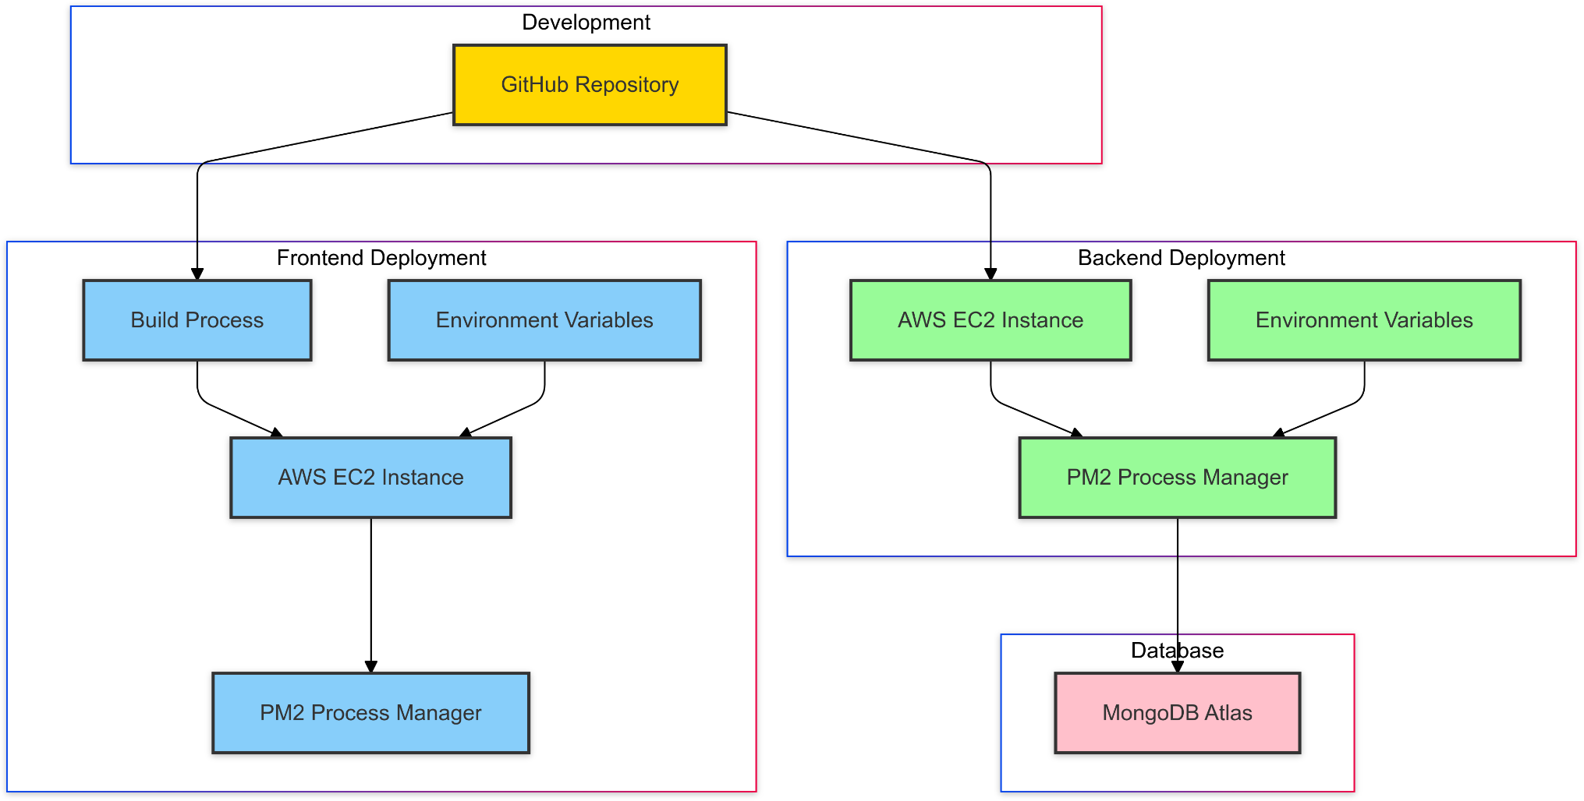

# Future Enhancements



### Technical Improvements

#### Switch to TypeScript:

* + Introduce TypeScript for type safety and better maintainability.

#### State Management Library:

* + Implement Redux, Context API, Zustang for more complex state needs.

#### Better UI:

* + Implement Better UI for the users to enjoy and interact.

### Feature Enhancements

#### Voice Chat:

* + Allow users to voice chat with players in the same room.

#### Video Chat:

* + Implement a social feature where users can Video Chat each other.

#### Notifications:

* + Real-time notifications for interactions.

#### Search Functionality:

* + Implement search to find public spaces by title, users, or tags.

#### Analytics Dashboard:

* + Provide users with insights on Room info, visits and interactions.

# Conclusion

The GatherAll project showcases an emerging concept in virtual environments, focusing on creating an interactive, immersive experience. It integrates JavaScript for functionality, with a clear structure for future development. As the project evolves, further features and improvements could be added, expanding its potential applications in virtual spaces.